[Month Day, Year]

TO: [Project Office Engineer, Title, Phone, Email]
WSDOT [specify region] Region Project Engineer’s Office

THROUGH: Luke Assink, Hydraulics and Floodplain Design Manager, 360-705-7269, AssinkL@wsdot.wa.gov
Julie Heilman, State Hydraulics Director, 360-705-7262, heilmaj@wsdot.wa.gov

FROM: [Name, Title, Phone, Email]

SUBJECT: [I/US/SR] [XXX] MP [XX.X] [XXXX Creek/River] [Describe project type (e.g., Fish Passage Barrier Removal, water crossing, bank protection, etc.)] Project – Flood Risk Assessment

Purpose
The Flood Risk Assessment (FRA) is a communication tool to identify if there are potential risks of meeting FEMA, local jurisdiction and public health and safety requirements in the preliminary stages of design. The FRA also identifies subsequent deliverables (e.g., floodplain analysis, no-rise, zero-rise, conditional letter of map revision (CLOMR), etc.) that may be needed for the permitting process. This preliminary assessment should allow the PEO and other disciplines to know if the project may need a CLOMR, easement, right-of-way (ROW), temporary construction easement (TCE), etc. allowing the project schedule and budget to be modified, if needed, early in the project delivery process.

Introduction
The Washington State Department of Transportation (WSDOT) requires proposed projects [specify one of the following: [located within a Special Flood Hazard Area (SFHA) / that are not located within a SFHA be considered under the Fish Habitat Enhancement Project (FHEP) program,] to be documented in an FRA during the preliminary stage of design. The FRA identifies if there are potential risks 1) of meeting Federal Emergency Management Agency (FEMA) Code of Federal Regulations (CFR) requirements; 2) of meeting local jurisdiction code floodplain development requirements; and 3) to public health and safety in order for a project to be considered for permitting as a fish habitat enhancement project, as required per RCW 77.55.181.
[Specify WSDOT or name of firm] assessed the potential effects [if not in a SFHA delete, if in a SFHA use the following: on the FEMA effective SFHA [specify FEMA SFHA Zone (e.g., Zone A, Zone AE, etc.)]] from replacing the existing infrastructure at the [Interstate/United States/State] Route ([I/US/SR]) [XXX] Mile Post (MP) [XX.X] crossing of [XXXX Creek/River]. The two-dimensional (2D) model developed for the Preliminary Hydraulic Design (PHD), which assessed the existing and proposed preliminary project conditions during the 1-percent annual exceedance probability (AEP) (100-year) flood, was utilized. The peak flow[s] corresponding with the 1-percent AEP (100-year) flood in the [if not in a SFHA with a detailed study (e.g. Zone AE) delete the FEMA flow portion, if in a SFHA use all of the following: effective Flood Insurance Study (FIS) No. [XXXXXV000], published in [Month, Year] (FEMA, [Year]) and the 1-percent AEP (100-year) flood, which was developed using best available methods, and more recent data, as part of the PHD (WSDOT, 20[XX])] was used for the 2D floodplain model flood risk assessment. The existing and proposed conditions results from the 2D hydraulic models were compared to determine 1) how the project may affect floodplain water surface elevations (WSEs) and extents and 2) assess how these differences may pose potential risks to public health and safety.

Project Description
WSDOT is proposing a replacement structure for the [I/US/SR] [XXX] crossing of [XXXX Creek/River] at Mile Post (MP) [XX.X], which is located approximately [XX.XX] miles [add direction] of [specify City], WA, in Water Resource Inventory Area (WRIA) [XX] (Figure 1). The existing [X]-foot [diameter/span], [XX]-foot long [specify existing crossing type (e.g., corrugated metal pipe (CMP))] on [I/US/SR] [XXX] was identified as a fish barrier by the Washington Department of Fish and Wildlife (WDFW) and the WSDOT Environmental Services Office (ESO) (WDFW Site ID [XXXXXX]), due to [specify barrier type (e.g., excessive velocity, flow depth, drop height)] required for fish passage (WDFW, 2009). The proposed project will replace the existing [specify existing crossing type (e.g., CMP)] with a structure having a minimum hydraulic width of [XX]-feet for the [add direction(s)] lanes of [I/US/SR] [XXX]. The WSDOT proposed project also includes associated channel grading and habitat features, including [describe project elements and reference the PHD (if complete) (e.g., Large Woody Material (LWM) structures, habitat boulders, and meander bars (WSDOT, [20XX])].

FEMA SFHA Minimum Requirements
[If project is not in a FEMA SFHA, do not use the text below (e.g., specify: This project is not within a FEMA SFHA, however there is still potential for flood risk which is evaluated for local jurisdiction code requirements in Section 2.3 and public health and safety in Section 3.3.2.)]
The effective FEMA Flood Insurance Rate Map (FIRM) Number [XXXXXXX], published in [Month, Year], shows [XXXX Creek/River], upstream and downstream of the [I/US/SR] [XXX] crossing, is in a mapped SFHA [specify FEMA SFHA Zone (e.g., Zone A, Zone AE, Zone X, etc.)] (Figure 2) with [specify if there are (or are not) Base Flood Elevations (BFEs) and a delineated floodway, which will be dependent on SFHA type][(Add Reference)]. [Check if preliminary FIRM/FIS data is available. If available, describe what was updated near the project site for the preliminary study (e.g., vertical datum conversion only, updated hydrologic/hydraulic modeling, etc.). Also add language if communication with the local Community/FEMA has taken place regarding whether preliminary or effective mapping should be used for the analysis.]. [Dependent of FEMA SFHA, describe FEMA requirements (e.g., allowance of X.XX feet rise), which should be noted are the minimum requirements and local jurisdiction code requirements will always govern.].

Local Community Code Requirements
The [I/US/SR] [XXX] [XXXX Creek/River] project is located in a [specify FEMA SFHA Zone (e.g., Zone A, Zone AE, Zone X, etc.)] within [specify local jurisdiction]. Section [XX.XX.XX(X)(x)] of the [specify local jurisdiction pertinent code] Code requires any project within a [specify one of the following: FEMA mapped SFHA or local jurisdiction requirement] [specify FEMA SFHA Zone (e.g., Zone A, Zone AE, Zone X, etc.) or local jurisdiction requirement] [with/without] a determined floodway, as is the WSDOT proposed project, must not increase the floodplain water surface elevations (WSEs) of the base flood (i.e., the 1-percent AEP (100-year) peak flow) by more than [specify local jurisdiction pertinent code requirements, (e.g., X.XX feet)].
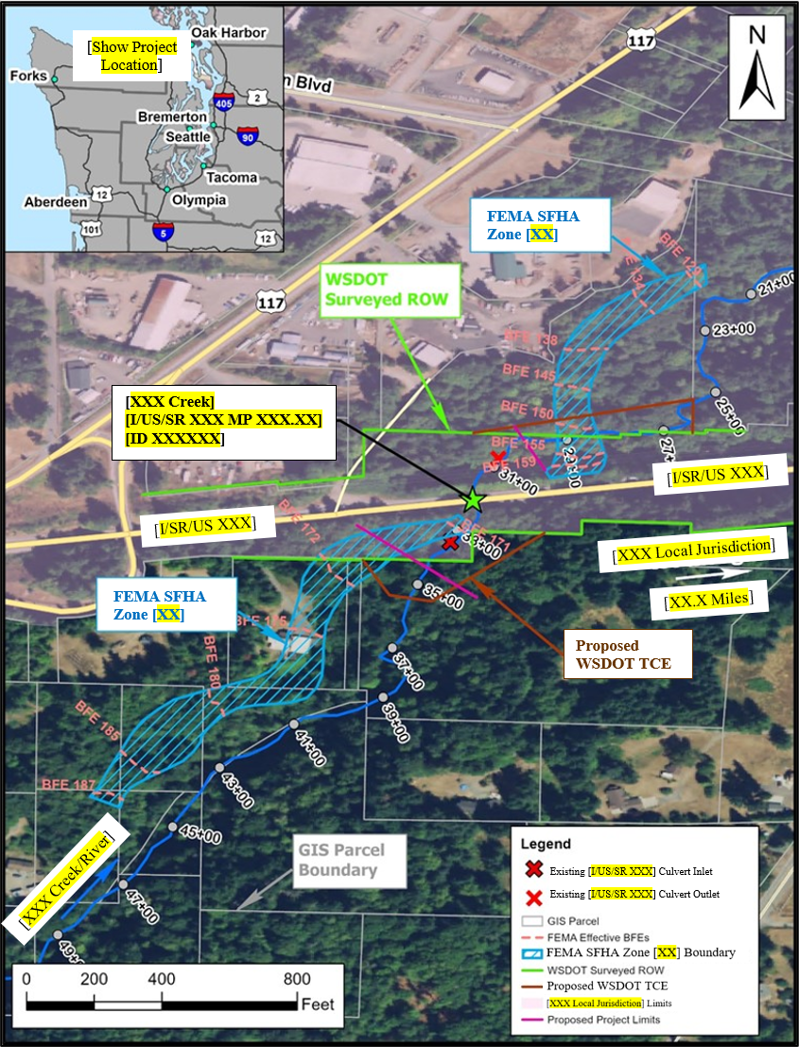
Figure 1 [I/US/SR] [XXX] [XXXX Creek/River] [Type of Project (e.g., Culvert Replacement)] Project Site with FEMA Floodplain Data.
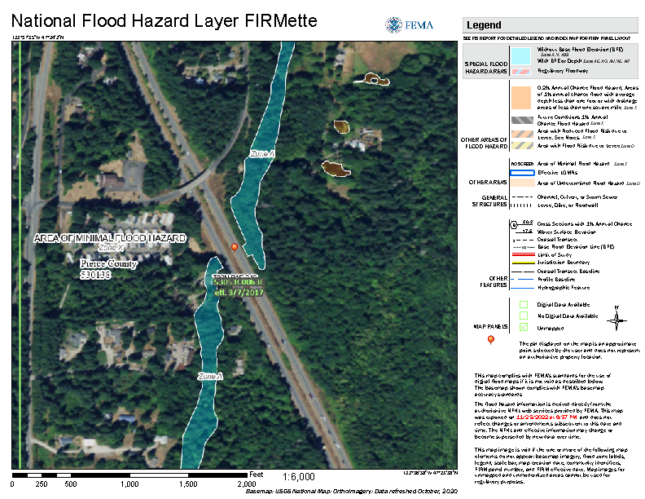
Figure 2 [I/US/SR] [XXX] [XXXX Creek/River] [Type of Project (e.g., Culvert Replacement)] Project Site with FEMA FIRM.

Flood Risk Assessment
[Specify WSDOT or name of firm] completed the following technical tasks for the proposed [I/US/SR] [XXX] [XXXX Creek/River] crossing: 1) performed an assessment of the project site; 2) compiled topographic, hydrologic, FEMA SFHA and local jurisdiction data; 3) developed an existing (i.e. pre-project) conditions 2D floodplain model; 4) developed a proposed (i.e. post-project) conditions 2D floodplain model; 5) compared the proposed to existing conditions WSEs for the 1-percent AEP e (100-year) peak flow[s]; and 6) assessed potential risks and project effects to public health and safety. [If not in a SFHA with a detailed study (e.g. Zone AE) leave as is, if in a SFHA with 1-percent AEP (100-year) flows that differ from PHD 1-percent AEP (100-year) flows, add the following: Task 3 through Task 6 above were completed for two scenarios, specifically: 1) utilizing effective FEMA information (Section 3.3.1) and 2) utilizing PHD information (Section 3.3.2).] These tasks are discussed in detail in the following sections. All elevations specified in this memo are referenced to the NAVD88 vertical datum.

Site Assessment
[Describe project site existing conditions; reference Figure 3]. [Describe existing project features/conditions (e.g., X-foot corrugated metal pipe (CMP) with metal wingwalls that conform to the surrounding ground, X-span bridge, bank protection, habitat restoration, etc.)]. [Describe stream conditions upstream and downstream of the project site; reference Figure 4 and Figure 5].
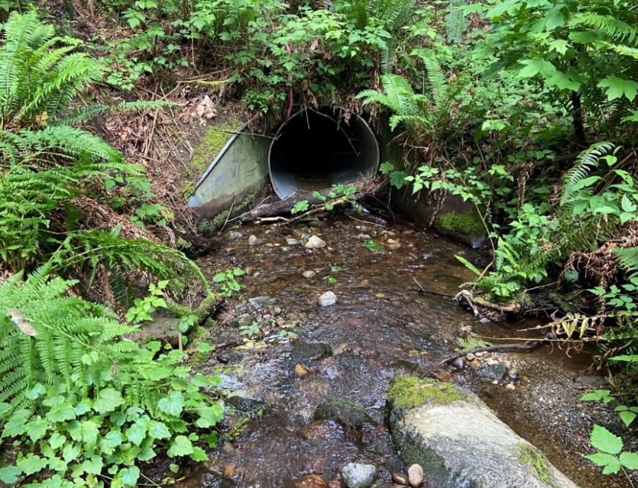
[Existing features (e.g., [X]-foot diameter/span pipe)]
[Name Creek/River]
Figure 3 Existing [I/US/SR] [XX] MP [XX] [Project Site Location (e.g., Culvert)]
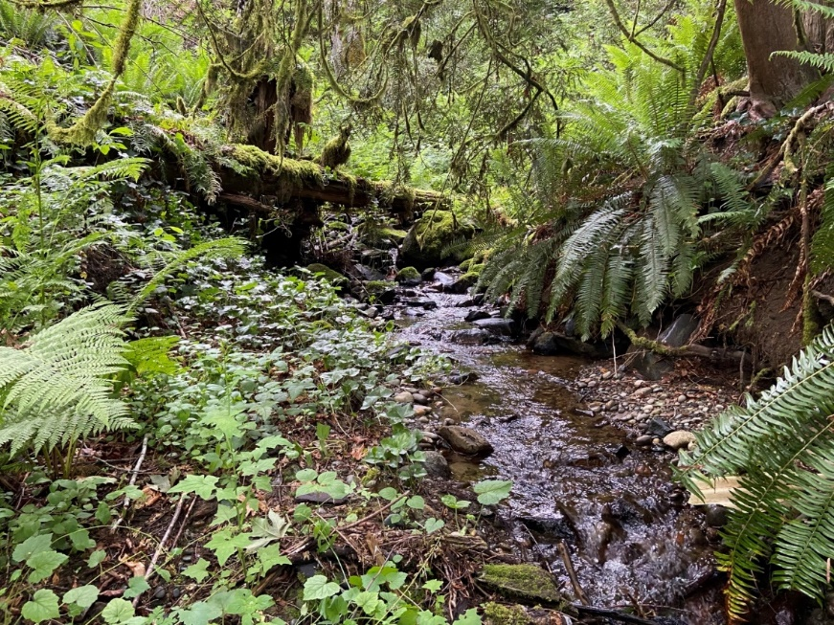
[Name Creek/River]
Figure 4 Upstream Reach Conditions
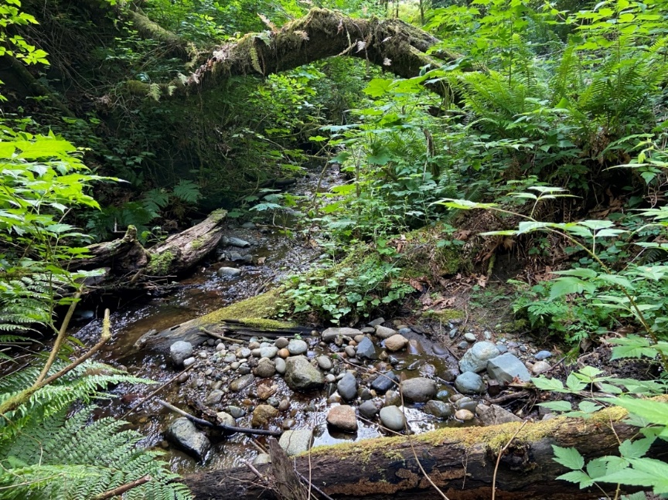
[Name Creek/River]
Figure 5 Downstream Reach Conditions

[Describe the reach and any parcels with structures (if no structures, state "no nearby parcels were identified containing structures within the mapped 100-year WSE.") (e.g., downstream of the [I/US/SR] [XXX] crossing, [XXXX Creek/River] has historically downcut into the underlaying glacial recessional material, thereby creating a terrace on its left overbank area. A private property is located on this terrace within parcel number [XXXXXXXXXX] (Figure 1) that is, at a minimum, [XX] feet above the present creek bed (Figure 6).]
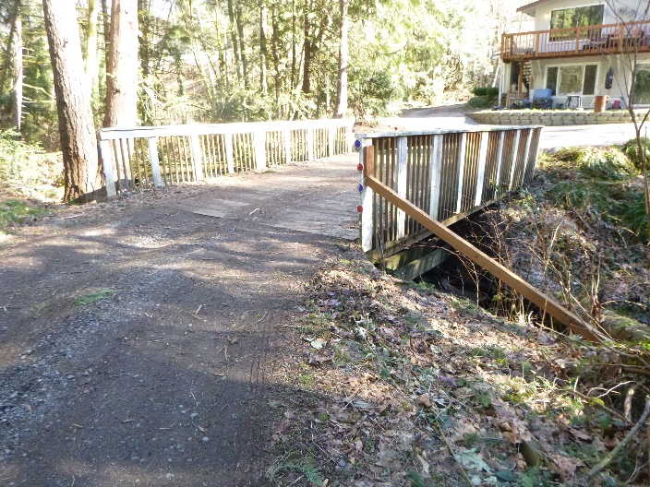
[XXXX Creek/River]
[Specify Property]
Figure 6 [Specify Property] Roughly [XXX] Feet
[location (e.g., Downstream)] of [I/US/SR] [XX] MP [XX]

Data Compilation

Topographic Data
Topographic survey data of the project site were collected by the [Describe agency/consultant who performed survey, the survey date (month day, year) and survey extents. The survey shall be certified/stamped by a Professional Land Surveyor (PLS) or a licensed engineer representing the agency responsible for the survey, registered in the State of Washington; indicate accordingly. Field survey limits shall include longitudinal extents (upstream and downstream) for a proper downstream boundary condition and upstream convergence of the water surface elevation profile; proper lateral extents shall span the inundation limits] and used to develop the corresponding existing conditions terrain surface. The topographic survey included the WSDOT right-of-way (ROW), both upstream and downstream of the crossing, and [describe additional topography collected from nearby property and structures (e.g., ground points taken around the private residence on the downstream overbank area]. [If a TCE is not needed no need for this portion; if a TCE is anticipated to be need but has not been identified or communicated with the PEO, describe and reference Figure 1; if a TCE has been determined use the following: TCE lines were subsequently determined by [specify Project Engineering Office (PEO) or firm] (Figure 1).] The topographic surface for the proposed conditions terrain was developed by [specify either PEO or firm] by modifying the existing terrain data to reflect the anticipated post-project site geometry [describe the proposed conditions geometry and note any assumptions or features that may change as the design progresses (e.g., structure selection, updates to roadway grading, etc.)]. The parcel boundaries were acquired from the publicly available Geographical Information Systems (GIS) database maintained by [specify data source]. [Describe the parcel boundaries and ROW lines (e.g., The boundary of the adjacent GIS parcel, southwest of the project site, crosses [XXXX Creek/River] downstream of [I/US/SR] [XXX] and deviates from the surveyed WSDOT ROW line (Figure 1). Because of this discrepancy, hydraulic results were evaluated at observation lines extracted along both the WSDOT ROW line and the GIS parcel boundary crossing [XXXX Creek/River] downstream of [I/US/SR] [XXX] (Figure 1).]

Hydrologic Data
The hydrologic data in this FRA is used to assess: 1) meeting FEMA requirements [if not in a SFHA with detailed study leave as is, if in a SFHA with a detailed study add the following: utilizing effective FEMA 1-percent AEP e (100-year) flood flows from the effective FIS Number [XXXXXV000], published in [Month, Year] (FEMA, [Year]]; 2) meeting local jurisdiction code requirements utilizing [Specify effective FEMA flows (if available) or other, as defined by local jurisdiction]; and 3) potential risks to public health and safety based on best available flow information developed as part of the PHD.
[Choose one of the following to describe 1-percent AEP (100-year) flood flow(s):]
[If in a SFHA with a detailed study and the 1-percent AEP (100-year) flood flow used for FEMA and the PHD are different state: The FEMA 1-percent AEP (100-year) flood flow of [XXX] cfs is used in the analysis presented in Section 3.3.1. The PHD recommends a 1-percent AEP (100-year) flood flow using best available flow information [describe best available flow information] for design of [XXX] cfs and is used in the analysis presented in Section 3.3.2.]
[If in a SFHA with a detailed study and the 1-percent AEP (100-year) flood flow used for FEMA and the PHD are the same state: The FEMA 1-percent AEP (100-year) flood flow of [XXX] cfs is used in the analysis presented in Section 3.3.1 and was also recommended by the PHD to be used for design.]
[If in a SFHA with no detailed study or not in a SFHA state: The PHD recommends a 1-percent AEP (100-year) flood flow for design of [XXX] cfs and is used in the analysis presented in Section 3.3.2.]
Additional information on the hydrologic data and analyses is available in the PHD ([reference WSDOT PHD]).

FEMA and Local Jurisdiction SFHA Data
The boundary of the SFHA Zone [specify FEMA/Local Jurisdiction SFHA Zone (e.g., Zone A, Zone AE, Zone X, etc.)] delineation, near the project site, was assessed and acquired from [specify the location the SFHA data was acquired from (e.g., the National Flood Hazard Layer (NFHL) or the FEMA Map Service Center) for [specify local jurisdiction] (FEMA, 20[XX])]. [Describe the location of the effective SFHA (if available) in proximity to the topography and the PHD 2D hydraulic results (e.g., per the effective FIRM, the delineated Zone [specify FEMA SFHA Zone (e.g., Zone A, Zone AE, Zone X, etc.)] deviates from the surveyed existing culvert inlet and outlet by roughly [XXX] and [XXX] feet, respectively] (Figure 1). [Please note not all projects will have digital data shown at the FEMA Map Service Center or available for download at the National Flood Hazard Layer website. In the case digital data is not available, it is not uncommon for the FEMA SFHA Zone boundary to not align with the actual creek location. If this is the case for your project, document accordingly and contact HQ Hydraulics for further assistance.] [If within a FEMA SFHA detailed study area, add description for status of obtaining effective FEMA model. Provide description of model (e.g., is it a pdf, HEC-2, RAS 1D, not able to be found by FEMA or local jurisdiction, etc.).]

2D Floodplain Model Development
The hydraulic analyses for the existing [I/US/SR] [XXX] [XXXX Creek/River] crossing was performed by [specify WSDOT or name of firm] utilizing SRH-2D (U.S. Bureau of Reclamation, 2020), a 2D, depth-averaged hydraulic and sediment transport numerical model that is included in the Surface-water Modeling System (SMS) Version [13.1.13] (Aquaveo, 2020) graphical user interface. [Describe the hydraulic roughness (Manning’s n) values assigned to the existing and proposed conditions models (e.g., the hydraulic roughness (Manning’s n) values assigned to the existing and proposed conditions models were based on standard values listed in Open-Channel Hydraulics (Chow, 1959) and recommended by FHWA (2008) for the land cover types observed at the site.] The mesh development and selected hydraulic roughness values for the existing and proposed conditions models are described in detail in [reference WSDOT PHD]. [Provide description for the downstream boundary conditions used in models described in Section 3.3.1 and 3.3.2] The existing and proposed models assume a steady-state condition and a fixed bed. Due to the fixed bed assumption, the existing and proposed meshes reflect the topography at the time of survey and immediately post-construction and do not deform in response to sediment transport or movement of LWM ([reference WSDOT PHD]).

2D Floodplain Model Development – Utilizing Effective FEMA FIS and FIRM Information [If project is not in a FEMA SFHA, do not use this section.]
[Note: FEMA models are not used for the FRA, only the FEMA 1-percent AEP (100-year) flood flow and BFE for downstream boundary condition from the effective FIS and FIRM should be used.] The existing and proposed conditions 2D floodplain model described in Sections 3.3.1.1 and 3.3.1.2, along with the corresponding results comparisons (Section 3.3.1.3) and assessment of flood risk (Section 3.3.1.4), utilized the FEMA 1-percent AEP (100-year) flood flow (Section 3.2.2). In addition to the FEMA flow specified as the upstream boundary condition, the 2D floodplain model downstream boundary condition aligned with the effective FEMA BFE location and corresponding elevation.

Existing Conditions 2D Floodplain Model
An existing conditions 2D mesh was developed by discretizing the existing conditions topographic surface (see Section 3.2.1) with appropriate resolution to resolve the ground topography and hydraulic variables required for design. The hydraulics through the existing [X]-foot [diameter/span] [specify existing crossing type (e.g., corrugated metal pipe (CMP))] were computed by the HY-8 culvert analysis software (FHWA, 2021), which was associated with the existing conditions 2D model with an appropriate boundary condition. The HY-8 computations utilized the culvert geometry, type, and site data from the [specify who collected survey] survey and field observations. Manning’s n values in the channel ranged from [0.XXX] to [0.XXX] while values ranging from [0.XXX] to [0.XXX] were used to represent roughness on the floodplain. The existing culvert was modeled as a [specify existing crossing type (e.g., CMP)] with no blockage and a Manning’s n values of [0.XXX]. [Describe how closely the 2D existing conditions model matches WSEs from the effective FIS and FIRM. In particular, document if there are any discrepancies more than 0.5 feet in elevation between the modeled 2D discharge-weighted average WSE and the effective FEMA FIS/FIRM BFE at tie-in locations.]

Proposed Conditions 2D Floodplain Model
The proposed conditions mesh was developed based on the proposed conditions surface provided by the [specify who developed the proposed surface] to represent the preliminary post-project geometry of the [XXXX Creek/River] channel, floodplain, and [I/US/SR] [XXX] roadway embankments and structure. The WSDOT preliminary proposed project also includes associated channel grading and habitat features, including [describe project elements and reference the PHD (if complete), (e.g., LWM structures, habitat boulders, and meander bars) (see WSDOT, 2021 for details)]. Manning’s n values, in areas where no grading is expected to occur, matched the existing conditions. In the areas of the proposed preliminary project, Manning’s n values in the channel ranged from [0.XXX] to [0.XXX] while values ranging from [0.XXX] to [0.XXX] were used to represent roughness on the floodplain.

Comparison of Existing and Proposed 1-percent AEP (100-Year) Water Surface Elevations
The difference of the 1-percent AEP (100-year) existing conditions WSE from the proposed conditions WSE (proposed minus existing), upstream and downstream of the project site, is depicted in Figure 7. The negative values, shown with blue shades, indicate a WSE reduction from existing to proposed conditions. The positive values, shown with yellow/orange/red shades, indicate a WSE rise. [Specify color] shades in Figure 7 designates existing dry areas that become inundated under proposed conditions. Conversely, inundated areas under existing conditions that are dry under proposed conditions are represented with a [specify color] shade.
Based on the recommendations of FHWA (2019), the comparison of the proposed to the existing 1-percent AEP (100-year) WSE is performed along the [X.X-foot] WSE contours calculated from the existing conditions model, which are the red color WSE contour lines in Figure 7. [If there is insufficient spacing due to low gradient or minimal model domain, additional observation lines may be needed to describe WSE differences (e.g. Because no [X.X-foot] existing WSE contours are located near the outlet of the existing culvert, where the largest 1-percent AEP (100-year) WSE difference is observed (Figure 7), [specify number of additional observation lines] additional observation lines strategically placed at Stations [specify stations (e.g. XX+XX and XX+XX] were considered in the 1-percent AEP (100-year) WSE comparison.]

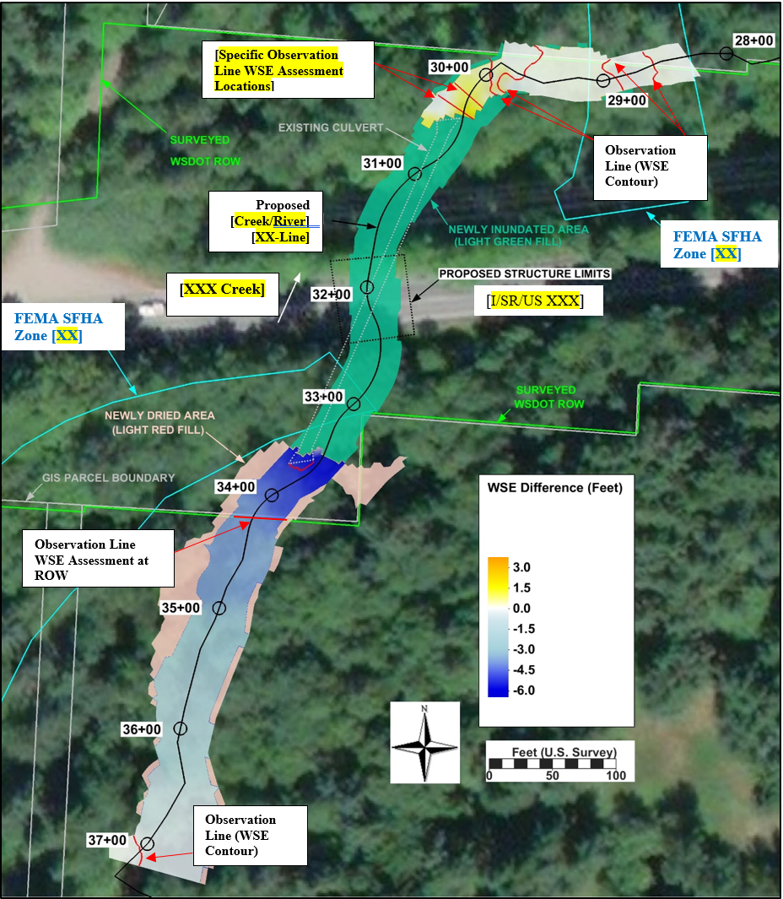
Figure 7 Difference of the Existing and Proposed 1-Percent AEP (100-Year) Water Surface Elevation Upstream and Downstream of the [I/US/SR] [XXX] Crossing.

PRIVATE DRIVEWAY BRIDGE
PRIVATE RESIDENCE
Section C-C (Station 49+89)
S
Section B-B (Station 50+03)
S
[Describe model comparison results upstream of crossing, for example: As depicted by the [specify color] areas in Figure 4, model results indicate that some areas upstream of the [I/US/SR] [XXX] crossing become inundated in response to the proposed grading. The WSE in these areas, however, reduces from existing to proposed conditions (Figure 8).]
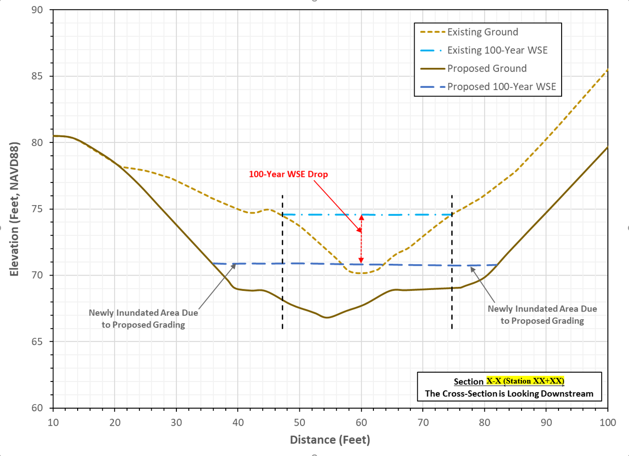
Figure 8 Comparison of the Existing and Proposed Conditions 1-Percent AEP (100-Year) Water Surface Elevation (WSE) at Observation Line [XX] Upstream of the [XXXX Creek/River] [I/US/SR] [XXX] Crossing.

The model results (downstream of [I/US/SR] [XXX]) indicate a [rise/reduction] in the 1-percent AEP (100-year) WSE downstream of the existing culvert outlet, as depicted by the [specify color] color in Figure 4. This [rise/reduction] is attributed to [Describe reason(s) why the project causes differences in WSE. For example, the replacement of the existing [X]-foot [diameter/span] [specify existing crossing type (e.g., corrugated metal pipe (CMP))] with the proposed wider channel. The wider proposed channel eliminates the fast and shallow flow downstream of the existing culvert outlet and establishes a slower and deeper flow under proposed conditions (WSDOT, 20[XX])].
[Describe any other pertinent locations where differences in WSE may be needed (e.g., The 1-percent AEP (100-year) WSEs predicted by the existing and proposed models along the WSDOT ROW line (observation line [XX]), and the boundary of the adjacent GIS parcel (observation line [XX]), are compared in Figure 9 and Figure 10, respectively.] The WSE comparisons utilize the discharge-weighted average existing and proposed 1-percent AEP (100-year) WSEs at these observation lines, in accordance with the recommendations of FHWA (2019). [If needed, reference other pertinent locations with additional figures (e.g., As depicted in Figures 6 and 7, the average 1-percent AEP (100-year) WSE [rise/reduction] along both observation lines [XX] and [XX] is less than [X.XX] [feet/foot], measuring at [X.XX] [feet/foot].]

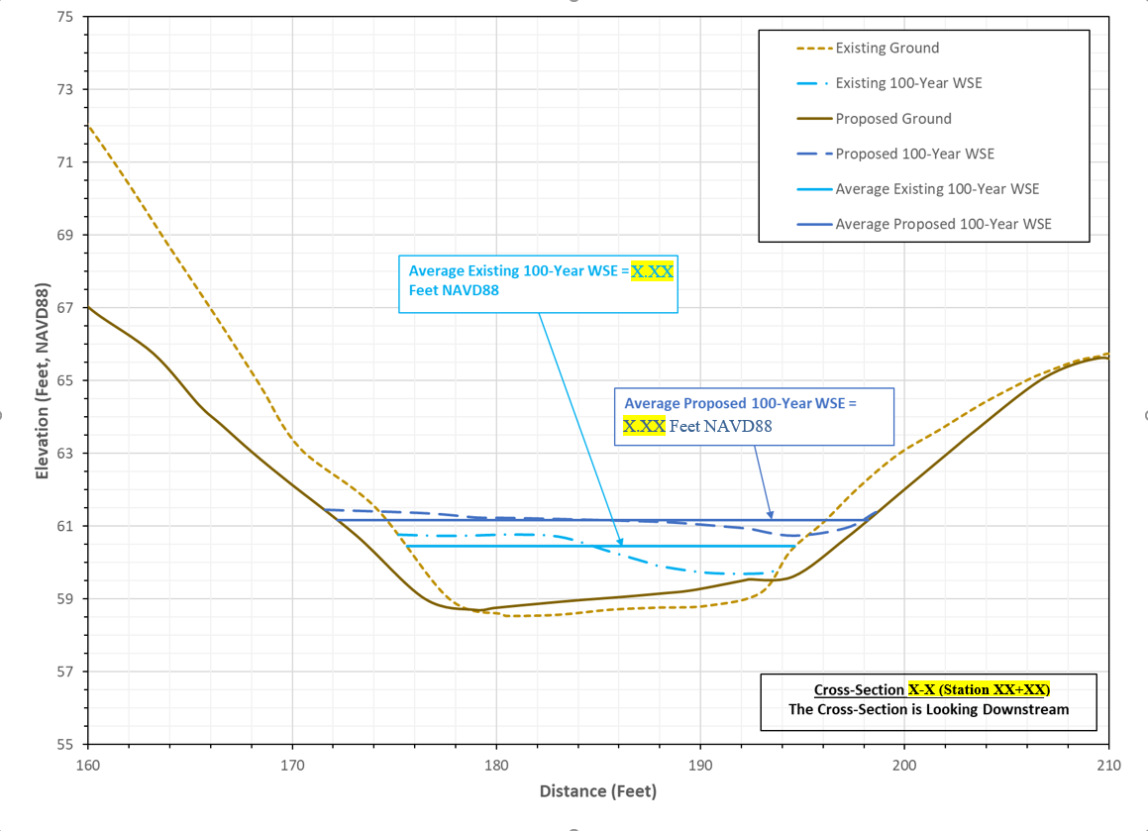
Figure 9 Comparison of the Existing and Proposed Conditions 1-Percent AEP (100-Year) Water Surface Elevation (WSE) at Observation Line [XX] Along the Surveyed WSDOT ROW Line.

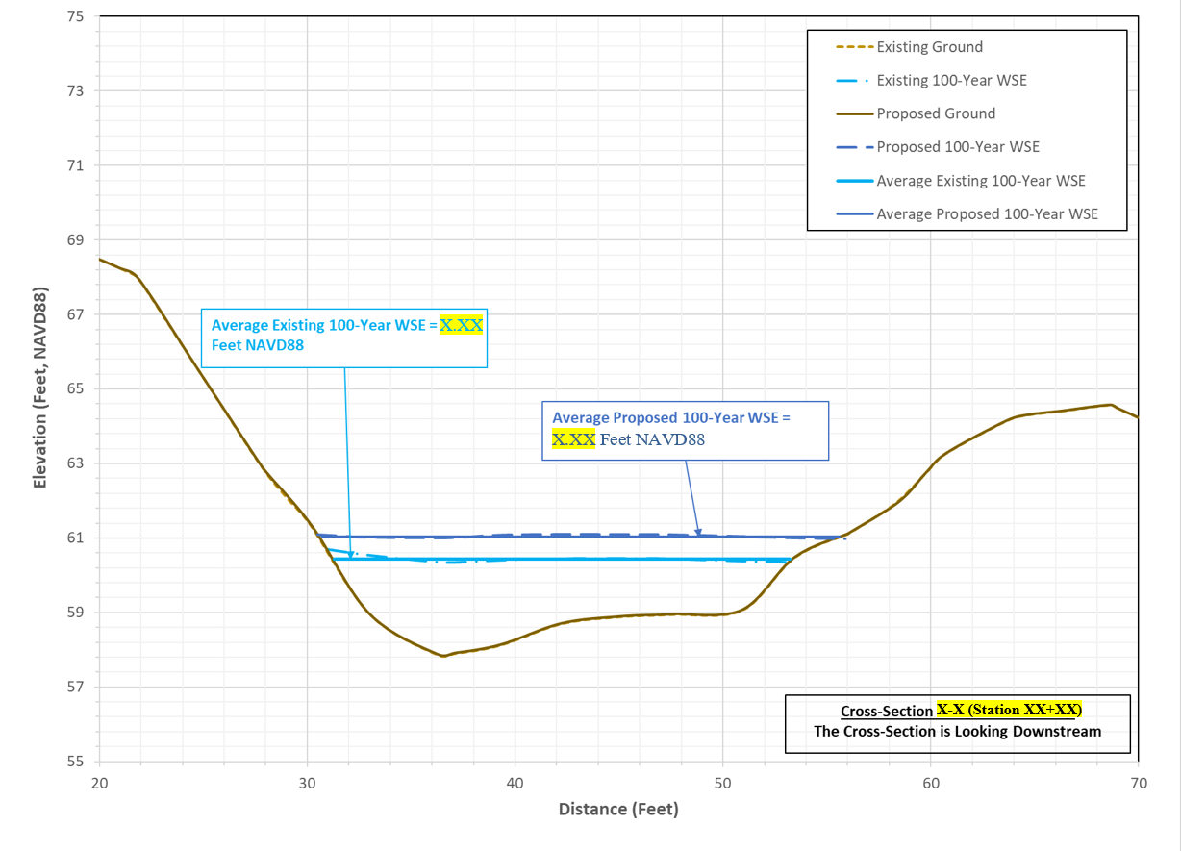
Figure 10 Comparison of the Existing and Proposed Conditions 1-Percent AEP (100-Year) Water Surface Elevation (WSE) at Observation Line [XX] Along the Adjacent Parcel Boundary Crossing [XXXX Creek/River].

The 1-percent AEP (100-year) discharge weighted WSEs (for both the existing and proposed conditions) along the [X.X-foot] contours and the additional observation lines at Stations [XX+XX] and [XX+XX], along with their differences, are summarized in Table 1. The results in Table 1 show that the [rise/reduction] in the average 1-percent AEP (100-year) WSE from existing to proposed conditions is [describe the results in relation to FEMA and local jurisdiction requirements, (e.g., less than one foot for Zone A)] at [describe how many locations examined meet criteria] locations downstream of the [I/US/SR] [XXX] crossing. The largest rise in the average 1-percent AEP (100-year) WSE is observed at Station [XX+XX], [XX+XX], [specify if they are within or out of WSDOT ROW]. Upstream of the US 101 crossing (Stations [XX+XX] and [XX+XX]), the WSDOT proposed project creates up to [X.XX] feet of drop in the average 1-percent AEP (100-year) WSE, as it eliminates the backwater effects due to the existing culvert. The resulting 1-percent AEP (100-year) WSE drop reduces the inundation extents of the creek floodplain (Figure 7 through [Figure 10]).

Table 1 Summary of Existing and Proposed Discharge Weighted Water Surface Elevations (WSEs) for the 1-Percent AEP (100-Year) Peak Flow
Observation Line Number | Station  (Feet) | Existing  (Feet, NAVD88) | Proposed  (Feet, NAVD88) | Difference  (Feet)
[X] | [XX+XX] | [XXX.XX] | [XXX.XX] | [X.XX]
[X] | [XX+XX] | [XXX.XX] | [XXX.XX] | [X.XX]
[X] | [XX+XX] | [XXX.XX] | [XXX.XX] | [X.XX]
[X] | [XX+XX] | [XXX.XX] | [XXX.XX] | [X.XX]
[X] | [XX+XX] | [XXX.XX] | [XXX.XX] | [X.XX]
[X] | [XX+XX] | [XXX.XX] | [XXX.XX] | [X.XX]
[X] | [XX+XX] | [XXX.XX] | [XXX.XX] | [X.XX]
[X] | [XX+XX] | [XXX.XX] | [XXX.XX] | [X.XX]
[X] | [XX+XX] | [XXX.XX] | [XXX.XX] | [X.XX]
[X] | [XX+XX] | [XXX.XX] | [XXX.XX] | [X.XX]

Assessment of Flood Risk
[The purpose of this section is to describe the potential risk of the preliminary design not being able to meet either FEMA SFHA minimum requirements or local jurisdiction code requirements and thus the project requiring a change in the design or a CLOMR. This is also a section where if the project does reside in a SFHA and the FEMA maps are incorrect, there may be a need to communicate to the local jurisdiction that the maps are incorrect and see if FEMA can update maps. As described in Section 3.2.1, note any assumptions or features that may change as the design progresses (e.g., structure selection, updates to roadway grading, etc.)]
[Describe how changes in modeled WSE or flood extents may affect identified property and structures identified in Section 3.1 (e.g., as discussed in Section 3.1, there is a private residence in the parcel adjacent to the proposed project) from the perspective of changing flood risk for flood insurance purposes.]
[If there is no rise on adjacent property or structures, document accordingly and there may not be a need for the following text.]
The predicted proposed conditions 1-percent AEP (100-year) inundation extents within [XXXX Creek/River], superimposed on the proposed conditions ground, are provided in Figure 11. The maximum 1-percent AEP (100-year) WSE around the [specify property and structures], under proposed conditions, is approximately [XXX.X] feet (NAVD88), whereas the lowest [ground/floor] elevation is [XXX.X] feet NAVD88. This suggests that the ground around the [specify property and structures] is about [XX.X] feet above the maximum 1-percent AEP (100-year) WSE that is predicted to occur near the [specify property and structures]. Therefore, the flooding risk from the proposed project on the [specify property and structures] [specify one of the following: is negligible or needs to be evaluated as the design progresses].

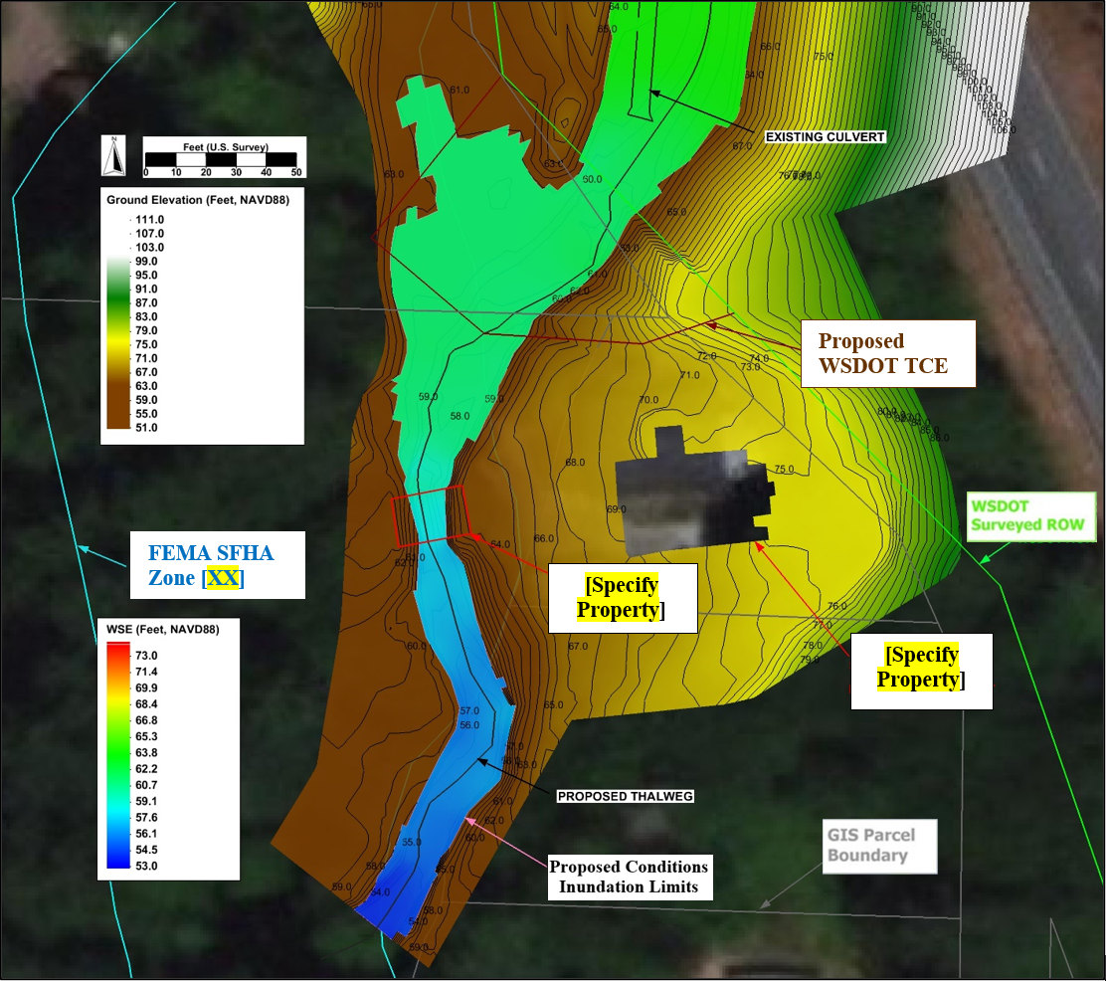
Figure 11 Proposed Conditions 1-percent AEP (100-Year) WSE, 1-Percent AEP (100-Year) Inundation Extents, and Ground Elevations.

2D Floodplain Model Development – Utilizing PHD Information
The existing and proposed conditions 2D floodplain model described in Sections 3.3.2.1 and 3.3.2.2, along with the corresponding results comparisons (Section 3.3.2.3) and assessment of flood risk (Section 3.3.2.4), utilized the 1-percent AEP (100-year) flood flow based on best available flow information developed as part of the PHD (Section 3.2.2). In addition to the PHD 1-percent AEP (100-year) flow specified as the upstream boundary condition, the 2D floodplain model downstream boundary condition assumed a [describe downstream boundary condition(s), need to evaluate proper tailwater conditions. For example, if in a tidal area, evaluate both riverine (e.g., normal depth) and range of tidal water surface elevations.)] as described in more detail in [reference WSDOT PHD].

Existing Conditions 2D Floodplain Model
An existing conditions 2D mesh was developed by discretizing the existing conditions topographic surface (see Section 3.2.1) with appropriate resolution to resolve the ground topography and hydraulic variables required for design. The hydraulics through the existing [X]-foot [diameter/span] [specify existing crossing type (e.g., corrugated metal pipe (CMP))] were computed by the HY-8 culvert analysis software (FHWA, 2021), which was associated with the existing conditions 2D model with an appropriate boundary condition. The HY-8 computations utilized the culvert geometry, type, and site data from the [specify who collected survey] survey and field observations. Manning’s n values in the channel ranged from [0.XXX] to [0.XXX] while values ranging from [0.XXX] to [0.XXX] were used to represent roughness on the floodplain. The existing culvert was modeled as a [specify existing crossing type (e.g., CMP)] with no blockage and a Manning’s n values of [0.XXX].

Proposed Conditions 2D Floodplain Model
The proposed conditions mesh was developed based on the proposed conditions surface provided by the [specify who developed the proposed surface] to represent the preliminary post-project geometry of the [XXXX Creek/River] channel, floodplain, and [I/US/SR] [XXX] roadway embankments and structure. The WSDOT preliminary proposed project also includes associated channel grading and habitat features, including [describe project elements and reference the PHD (if complete), (e.g., LWM structures, habitat boulders, and meander bars) (see WSDOT, 2021 for details)]. Manning’s n values, in areas where no grading is expected to occur, matched the existing conditions. In the areas of the proposed preliminary project, Manning’s n values in the channel ranged from [0.XXX] to [0.XXX] while values ranging from [0.XXX] to [0.XXX] were used to represent roughness on the floodplain.

Comparison of Existing and Proposed 1-Percent AEP (100)-Year Water Surface Elevations
The difference of the 1-percent AEP (100-year) existing conditions WSE from the proposed conditions WSE (proposed minus existing), upstream and downstream of the project site, is depicted in Figure 12. The negative values, shown with blue shades, indicate a WSE reduction from existing to proposed conditions. The positive values, shown with yellow/orange/red shades, indicate a WSE rise. [Specify color] shades in Figure 12 designates existing dry areas that become inundated under proposed conditions. Conversely, inundated areas under existing conditions that are dry under proposed conditions are represented with a [specify color] shade.
Based on the recommendations of FHWA (2019), the comparison of the proposed to the existing 1-percent AEP (100-year) WSE is performed along the [X.X-foot] WSE contours calculated from the existing conditions model, which are the red color WSE contour lines in Figure 12. [If there is insufficient spacing due to low gradient or minimal model domain, additional observation lines may be needed to describe WSE differences (e.g. Because no [X.X-foot] existing WSE contours are located near the outlet of the existing culvert, where the largest 1-percent AEP (100-year) WSE difference is observed (Figure 12), [specify number of additional observation lines] additional observation lines strategically placed at Stations [specify stations (e.g. XX+XX and XX+XX] were considered in the 1-percent AEP (100-year) WSE comparison.]

Figure 12 Difference of the Existing and Proposed 1-Percent AEP (100-Year) Water Surface Elevation Upstream and Downstream of the [I/US/SR] [XXX] Crossing.

[Describe model comparison results upstream of crossing, for example: As depicted by the [specify color] areas in Figure 12, model results indicate that some areas upstream of the [I/US/SR] [XXX] crossing become inundated in response to the proposed grading. The WSE in these areas, however, reduces from existing to proposed conditions (Figure 13).]
Figure 13 Comparison of the Existing and Proposed Conditions 1-Percent AEP (100-Year) Water Surface Elevation (WSE) at Observation Line [XX] Upstream of the [XXXX Creek/River] [I/US/SR] [XXX] Crossing.

The model results (downstream of [I/US/SR] [XXX]) indicate a [rise/reduction] in the 1-percent AEP (100-year) WSE downstream of the existing culvert outlet, as depicted by the [specify color] color in Figure 12. This [rise/reduction] is attributed to [Describe reason(s) why the project causes differences in WSE. For example, the replacement of the existing [X]-foot [diameter/span] [specify existing crossing type (e.g., corrugated metal pipe (CMP))] with the proposed wider channel. The wider proposed channel eliminates the fast and shallow flow downstream of the existing culvert outlet and establishes a slower and deeper flow under proposed conditions (WSDOT, 20[XX])].
[Describe any other pertinent locations where differences in WSE may be needed (e.g., The 1-percent AEP (100-year) WSEs predicted by the existing and proposed models along the WSDOT ROW line (observation line [XX]), and the boundary of the adjacent GIS parcel (observation line [XX]), are compared in Figure 14 and Figure 15, respectively.] The WSE comparisons utilize the discharge-weighted average existing and proposed 1-percent AEP (100-year) WSEs at these observation lines, in accordance with the recommendations of FHWA (2019). [If needed, reference other pertinent locations with additional figures (e.g., As depicted in Figure 14 and Figure 15, the average 1-percent AEP (100-year) WSE [rise/reduction] along both observation lines [XX] and [XX] is less than [X.XX] [feet/foot], measuring at [X.XX] [feet/foot].]
Figure 14 Comparison of the Existing and Proposed Conditions 1-Percent AEP (100-Year) Water Surface Elevation (WSE) at Observation Line [XX] Along the Surveyed WSDOT ROW Line.

Figure 15 Comparison of the Existing and Proposed Conditions 1-Percent AEP (100-Year) Water Surface Elevation (WSE) at Observation Line [X-X] Along the Adjacent Parcel Boundary Crossing [XXXX Creek/River].

The 1-percent AEP (100-year) discharge weighted WSEs (for both the existing and proposed conditions) along the whole [X.X-foot] contours and the additional observation lines at Stations [XX+XX] and [XX+XX], along with their differences, are summarized in Table 2. The results show that the [rise/reduction] in the average 1-percent AEP (100-year) WSE from existing to proposed conditions is [describe the results in relation to FEMA (if applicable) and local jurisdiction requirements, (e.g., less than one foot for Zone A)] at [describe how many locations examined meet criteria] locations downstream of the [I/US/SR] [XXX] crossing. The largest rise in the average 1-percent AEP (100-year) WSE is observed at Station [XX+XX], [XX+XX], [specify if they are within or out of WSDOT ROW]. Upstream of the [I/US/SR] crossing (Stations [XX+XX] and [XX+XX]), the WSDOT proposed project creates up to [X.XX] feet of drop in the average 1-percent AEP (100-year) WSE, as it eliminates the backwater effects due to the existing culvert. The resulting 1-percent AEP (100-year) WSE drop reduces the inundation extents of the creek floodplain (Figure 12 through [Figure 15]).

Table 2 Summary of Existing and Proposed Discharge Weighted Water Surface Elevations (WSEs) for the 1-Percent AEP (100-Year) Peak Flow
Observation Line Number | Station  (Feet) | Existing  (Feet, NAVD88) | Proposed  (Feet, NAVD88) | Difference  (Feet)
[X] | [XX+XX] | [XXX.XX] | [XXX.XX] | [X.XX]
[X] | [XX+XX] | [XXX.XX] | [XXX.XX] | [X.XX]
[X] | [XX+XX] | [XXX.XX] | [XXX.XX] | [X.XX]
[X] | [XX+XX] | [XXX.XX] | [XXX.XX] | [X.XX]
[X] | [XX+XX] | [XXX.XX] | [XXX.XX] | [X.XX]
[X] | [XX+XX] | [XXX.XX] | [XXX.XX] | [X.XX]
[X] | [XX+XX] | [XXX.XX] | [XXX.XX] | [X.XX]
[X] | [XX+XX] | [XXX.XX] | [XXX.XX] | [X.XX]
[X] | [XX+XX] | [XXX.XX] | [XXX.XX] | [X.XX]
[X] | [XX+XX] | [XXX.XX] | [XXX.XX] | [X.XX]

Assessment of Flood Risk
[The purpose of this section is to describe the potential risk(s) the preliminary design may have to public health and safety in order for a project to be considered for permitting as a fish habitat enhancement project, as required per RCW 77.55.181. This section should also describe the potential risk(s) of the preliminary design not being able to meet local jurisdiction code requirements. If there is risk to public health and safety or meeting local jurisdiction code requirements, need to describe whether the risks can be mitigated with a change in the preliminary design, or if a CLOMR or other condition per local jurisdiction code may be required. As described in Section 3.2.1, note any assumptions or features that may change as the design progresses (e.g., structure selection, updates to roadway grading, etc.)]
[Describe how changes in modeled WSE or flood extents may affect identified property and structures (e.g., as discussed in Section 3.1, there is a private residence in the parcel adjacent to the proposed project.) from the perspective of changing flood risk to public health and safety.]
[If there is no rise on adjacent property or structures, document accordingly and there may not be a need for the following text.]
The predicted proposed conditions 1-percent AEP (100-year) inundation extents within [XXXX Creek/River], superimposed on the proposed conditions ground, are provided in Figure 16. The maximum 1-percent AEP (100-year) WSE, under proposed conditions, is approximately [XXX.X] feet (NAVD88), whereas the lowest [ground/floor] elevation around the [specify property and structures] is [XXX.X] feet NAVD88. This suggests that the ground around the [specify property and structures] is about [XX.X] feet above the maximum 1-percent AEP (100-year) WSE that is predicted to occur near the [specify property and structures]. Therefore, any additional flooding risk (compared to existing conditions) from the proposed project on the [specify property and structures] [specify one of the following: is negligible or needs to be evaluated as the design progresses].

Figure 16 Proposed Conditions 1-Percent AEP (100-Year) WSE, 1-Percent AEP (100-Year) Inundation Extents, and Ground Elevations.

Summary
In summary, the WSDOT preliminary proposed [I/US/SR] [XXX] replacement structure, with associated channel grading and habitat features, [does/does not] cause an average rise in the 1-percent AEP (100-year) WSE larger than [X.XX] [feet/foot]] (Section[s] [3.3.1.3] and 3.3.2.3) and thus is anticipated to [meet/ not meet] [describe FEMA and local jurisdiction requirements] described in Section[s] [2.2] and [2.3]. [If in a FEMA detailed study area, summarize if the 2D existing conditions model matches WSEs from the effective FIS and FIRM. In particular, document if there are any discrepancies more than 0.5 feet in elevation between the modeled 2D discharge-weighted average WSE and the effective FEMA FIS/FIRM BFE at tie-in locations.] The preliminary design’s potential for flood risks associated with public health and safety, per RCW 77.55.181, are [summarize potential impacts to adjacent property and structures or if there are no impacts, state the preliminary design’s potential for flood risks associated with public health and safety per RCW 77.55.181 are minor based on the findings from this FRA] (Sections 3.3.1.4 and 3.3.2.4). [Describe potential changes that could be made to the preliminary design that may allow the final design to meet FEMA, local jurisdiction and health and safety requirements.] A [specify required subsequent assessment (e.g., no-rise / zero-rise / floodplain analysis / CLOMR / specify any other analyses or requirements)] is anticipated to be required for this project based on the preliminary design. If there are any changes to WSEs or inundation extents, then a Letter of Map Revision (LOMR) may be required after the project is constructed. Collaboration with [specify local jurisdiction], FEMA Region 10, and WSDOT should continue as the project progresses.

References
Aquaveo (20[XX]). Surface-water Modeling System v. [13.1.13].
Chow, V.T. (1959). Open Channel Hydraulics, McGraw-Hill book Company, NY.
[Update with appropriate FEMA and local jurisdiction references]
Federal Highway Administration (2019). Two-Dimensional Hydraulic Modeling for Highways in the River Environment - Reference Document. Federal Highway Administration Publication No. FHWA-HIF-19-061. https://www.fhwa.dot.gov/engineering/hydraulics/pubs/hif19061.pdf.
Federal Highway Administration (2021). HY-8 Culvert Hydraulic Analysis Program, Washington D.C. https://www.fhwa.dot.gov/engineering/hydraulics/software/hy8/.
Federal Highway Administration (2008). Introduction to Highway Hydraulics. Federal Highway Administration Publication Number NHI-08-090. http://www.fhwa.dot.gov/engineering/hydraulics/pubs/08090/appb.cfm.
Mastin, M.C., C.P. Konrad, A.G. Veilleux, and A.E. Tecca (2016). Magnitude, Frequency, and Trends of Floods at Gaged and Ungaged Sites in Washington, Based on Data through Water Year 2014: Scientific Investigations Report 2016-5118. United States Geological Survey. Reston, VA. https://pubs.er.usgs.gov/publication/sir20165118.
PRISM Climate Group (2015). 30-Year Normal Precipitation: Annual. Oregon State University. http://www.prism.oregonstate.edu/normals/ (Accessed May 2019).
United States Bureau of Reclamation (2020). Sedimentation and River Hydraulics – Two-Dimensional (SRH-2D) Model v3.
United States Geological Survey (2018). StreamStats in Washington. http://water.usgs.gov/osw/streamstats/Washington.html (January 2019).
Washington State Department of Fish and Wildlife (2019). Fish Passage and Diversion Screening Inventory Database- Level A Culvert Assessment Report for Site ID 933460. http://apps.wdfw.wa.gov/fishpassagephotos/Reports/933460_Report.pdf (accessed May 2019).
Washington Department of Fish and Wildlife (2009). Fish Passage and Surface Water Diversion Screening Assessment and Prioritization Manual. Washington Department of Fish and Wildlife. Olympia, Washington.
Washington State Department of Transportation (20[XX]). SR [XXX] MP [XX.XX] [XXXX Creek/River] Remove Fish Barrier Project: Preliminary Hydraulic Design Report. Washington State Department of Transportation. Olympia, WA.
If you have any questions or need further assistance regarding the information included in this memorandum, please feel free to contact Luke Assink at AssinkL@wsdot.wa.gov / (360) 705-7269, or [name of author(s)] [author(s) emails].

cc: [Add cc recipients]
HQ Hydraulics File

